Pattern Features
This pattern is designed to use stash yarn in double knitting. The Roman numeral designs are charted for M and C. The Roman for 900 is MCM so you may want to do two Ms.
The chart is in red as the background colour and yellow for the contrast numeral design but you may use any stash colours you like. The final size is approximately 10cm x 15cm.
The main body is worked in stocking stitch with rows at the beginning and end of different stitch (garter or moss stitch/seed stitch), to help prevent curling.
For the same reason I slipped the first stitch of each row.
Stocking stitch - Right side knit, wrong side purl.
Garter stitch - all rows knit.
Moss/Seed stitch - K1, P1 to the last stitch K1 each row – with an odd number of stitches.

Colour Changes
When changing colours you may want to carry the wool behind or use intarsia (twisting the two colours tightly together as you change colour) If you use stranding, there are some quite long carry across strands so take care to avoid bunching by carrying the wool loosely along the wrong side of the work. Stretching the stitches along the right hand needle, before changing back to the other colour makes this easier.

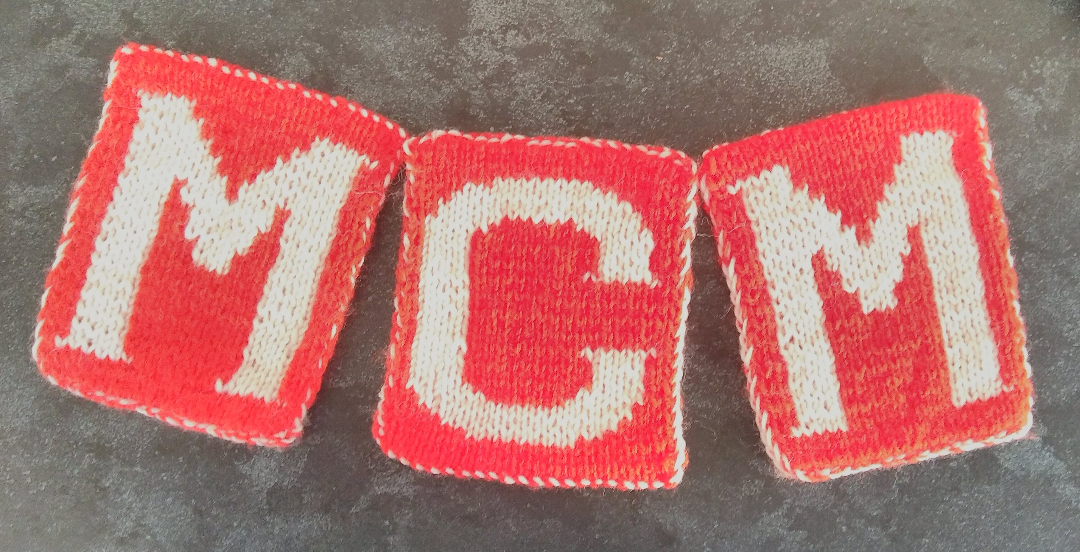
Needles and Tension
Needle size:3mm-4mm, depending on your tension. or wool chosen. Sizing is not exact but tension can be adapted using smaller needles to make it smaller or larger needles to make larger. If you use a thinner wool you may want to create extra rows and stitches at the edges to create a suitable size.
Wool and Abbreviations
Double knitting in 2 colours from stash.
MC main colour
CC contrast colour
K Knit
P Purl
Sl slip stitch purl wise from left to right needle

Patterns: Flag M
Cast on 23 stitches in MC.
Use chart for colours MC in red and CC in yellow.
Rows 1- 4 Knit in MC in garter or moss stitch/seed stitch
Commence 2 colour Roman Numeral pattern as per chart as follows:
Row 5: MC Sl1, K1 switch to CC K6, MC K7, CC K6, MC K2.
Row 6 MC Sl1 ,P2, CC P4, MC P9, CC P4, MC P3.
Continue following chart for colour changes, slipping the first colour in each row, until last 4 rows. Use garter or moss stitch to complete
Cast off loosely.
Sew in ends.
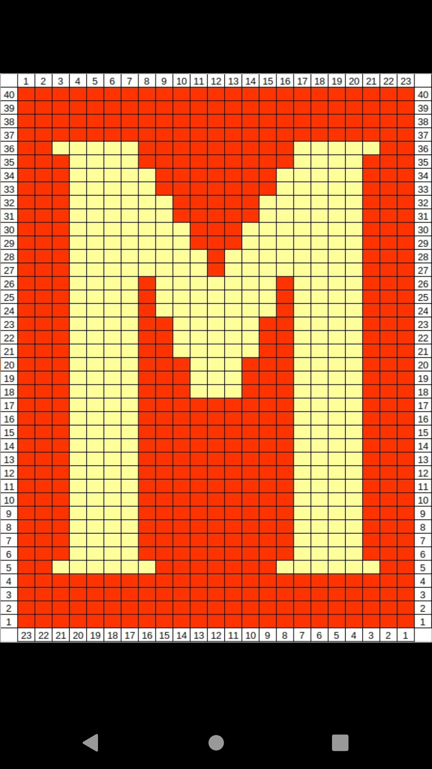
Charts

Flag C: More care is needed following the chart as it is not symmetrical. The reverse side of the C completed flag will be mirrored. The flags are displayed against a wall so this does not matter.

Knit odd rows and follow chart right to left, using bottom row of numbers for stitch count. Purl even rows and read from left to right using the stitch count line on the top of the chart .
Rows 1-4 are as for M pattern, in Main Colour
Row 5: MC Sl1, K7, CC K8, MC K7.
Row 6 MC Sl1 P4 CC P12, MC P6.
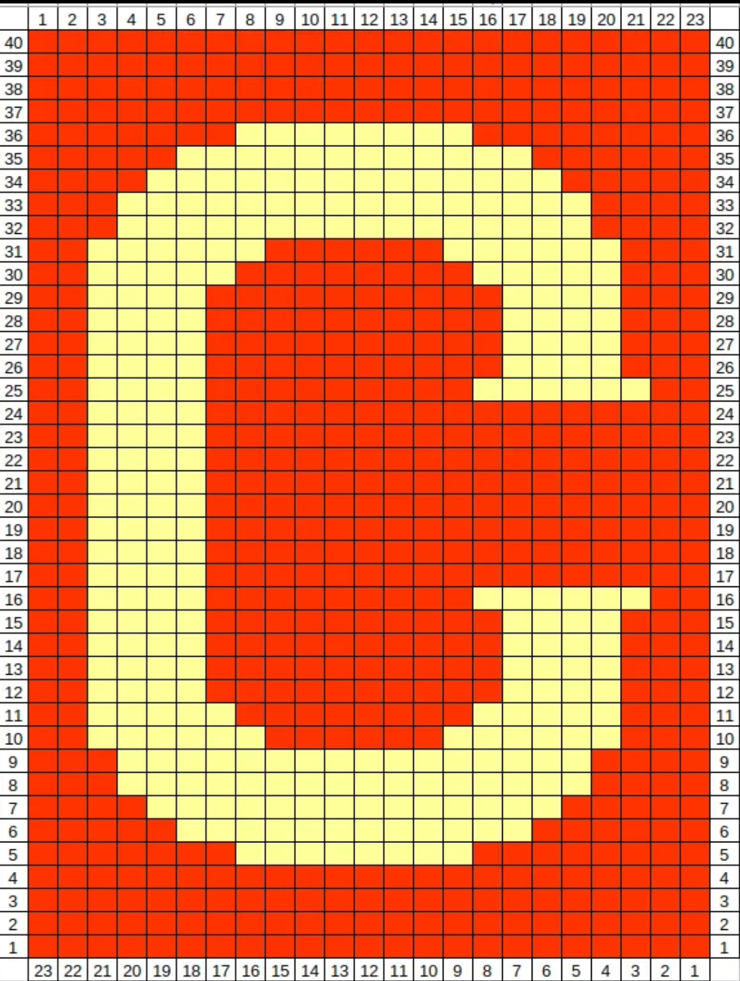
Continue following chart in this manner until 36 rows completed Complete last 4 rows as for M.

